

MetreosVisual Designer

Graphics Specification

January 1, 2005

Copyright © 2004-2005 Metreos Corporation
All rights reserved

Proprietary and confidential
For release under NDA only

Table of Contents

Background 3
Application Example 3
The Visual Designer from a Graphics Perspective 4
Icon Requirements 6
General Design Considerations 6
Action Icon Design 6
Icon Listing 7
32x32 Icons 7
16x16 Icons: Toolbox 8
16x16 Icons: Script Canvas 10
16x16 Icons: Project Explorer 11
16x16 Icons: Docking Windows 12
16x16 Icons: Designer Toolbars 13
Splash Screen Requirements 18
Appendix 20
Appendix A: Images We Like 20
Background
We are developing a traditional Windows client application which is essentially a visual design studio for Voice over IP applications. It is this application for which we require the digital artwork, in the form of icons and a splash screen graphics.

The prototype application, as shown in Figure 1, illustrates the application and its use of icons; however the icons shown are not necessarily representative of our expectations as to graphic design, nor do we own the rights to these icons – they are shown merely for example and placeholder purposes.

Figure 1: Visual Designer Prototype
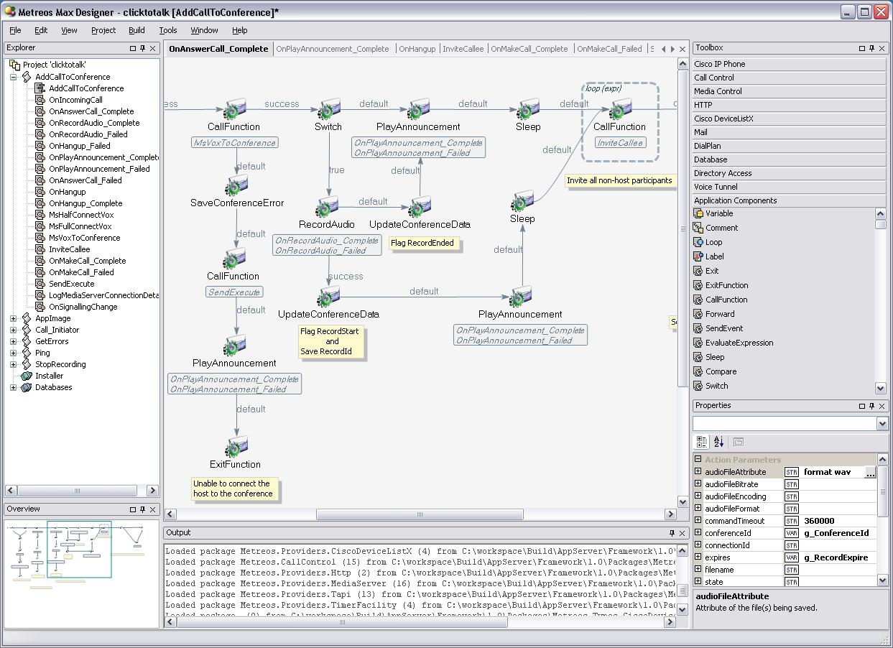

Application Example
A simple example of how a customer might use this application is this: a customer wishes to develop its own voice mail facility for their IP phone system. Simplistically, such a voice mail system would, among other things, do the following:
- Trigger (start) on any incoming call.
- Answer the call.
- If the answer call action fails, play an announcement asking the caller if s/he wishes to leave a message, and to press a certain key on their keypad if so.
- Get digits (keypad presses from the phone).
- Test if the any key was pressed and if so was it the voice mail request key. If not, exit.
- Play an announcement asking the caller to begin their message and to press a key when done.
- Begin recording.
- Get digits from the phone.
- etc. etc.

The Visual Designer from a Graphics Perspective

Actions, Tools, and the Toolbox
Our visual design studio will work by dragging and dropping action tools from the application’s toolbox onto an application canvas, and dragging arrows between the various actions to indicate logic flow. The subject of each of the items in the example list above is such an action. Furthermore, each action belongs to a certain tool group. For example list items 2 and 4 belong to the group named Call Control. Example entries 6 and 7 belong to tool group Media Control. Item 3 (If, or Switch) belongs to group Application Components. Each tool group has its own tab in the toolbox – clicking on a toolbox tab displays all the tools for that tool group. Each toolbox tab, and each action tool, has a 16x16 icon associated with it.

The Toolbar
Many activities selectable from a menu will have icons in an application toolbar. A toolbar is not shown in the application prototype illustration, however one or more such toolbars will be present. Note that a toolbar is not the same as the toolbox – items in a toolbar mirror menu items, while items in the toolbox represent canvas tools such as actions and events. Each toolbar item has a 16x16 icon associated with it.

Docking Windows
The visual designer application view contains various docking windows, as can be seen in Figure 1, such as the toolbox, the explorer, the property grid, and the output window. Each such docking window also has a 16x16 icon associated with it, which is displayed when the docking window is autohidden.

The Project Explorer
A visual designer project is displayed graphically in the explorer docking window. This view shows the project as a tree structure, with each entry in the tree displaying a 16x16 icon indicating the type of project component.

The Script Canvas
A visual designer project consists of one or more application scripts. A script may be thought of as a major division of the application. In the voice mail example, one script might be devoted to answering calls and leaving messages, with a second script handling message playback. A script consists visually of one script canvas, and one or more function canvases. The script canvas displays a tree view consisting of event and event handler components of the script, plus the global variables in the script. Each entry in the tree has a 16x16 icon associated with it.

Function Canvases
The user, building a telephony application with the visual designer, drags actions and other items from the toolbox onto a function canvas. These items are shown in the toolbox as 16x16 icons and on the canvas as 32x32 icons.

The Application
The visual designer application as a whole is represented on the desktop as a distinctive 32x32 icon, and within application title bars as a 16x16 version of the same icon. As loading a large project into the visual designer can take several seconds, it is desirable that a splash screen be displayed to the user waiting for the application to load.

Icon Requirements

General Design Considerations

We think that icons in general should exhibit a few common properties
- Simplicity of design
There should never be much detail in an icon. It is always preferable that an icon be simple, elegant, and well balanced, whether or not the icon content can be recognized as representing some real-world object or concept. To put it another way, it is far better for an icon to be abstract, simple, and attractive, than be an overly ambitious attempt at a tiny view of a concrete object.
- Simplicity of color
Two or three colors in gradients and alpha transparencies is usually sufficient.
- Harmony of colors
Blues, greens, grays, tans, gray-blues, gray-browns, with sparing use of reds, yellows and black seem to work best.
- Complexity of shading
Gradients should be used to the extent of resolution. We have also seen dithering used to good effect on small icons.
- Harmony with siblings
Icons should be attractive in combination with any other icons in the product. 16x16 icons should probably in general assume a basically rectangular presence, or at least be relatively straight along their left and top borders, in order that rows and columns of such icons appear linear and orderly.
- Harmony with the application
Many icons will be visible at any given time in the course of the application, and so no icon should call attention to itself, but rather it should be identifiable yet in harmony with its surroundings.

These are not to be construed as hard requirements, since exceptions may certainly work best in some cases. However when we make an exception we should be able to define why we have done so.

Action Icon Design

The most important icon in the visual designer is that which represents an action. An action is represented in the toolbox as a 16x16 icon, and on a designer canvas as a 32x32 icon. Many, possibly in excess of a hundred, actions could conceivably be visible on a canvas at any one time.

Action icons represent tools which perform activities within a voice over IP program. Some examples of actions are:
- Metreos.CallControl.AnswerCall
Answers the current incoming call.
- Metreos.CallControl.Hangup
Terminates the current call.
- Metreos.MediaControl.PlayAnnouncement
Plays a voice recording to one or more parties.
- Metreos.MediaControl.GetDigits
Identifies any keys a call party may have pressed.
- Cisco.IpPhone.CreateMenu
Show a text menu on an IP phone display.
- Metreos.ApplicationControl.EndFunction
Ends execution of the current visual designer function.
- Metreos.ApplicationControl.Switch
Tests the value of an expression and branches to another action accordingly.

Note that actions are identified qualified by their tool group. For example, for action Metreos.ApplicationControl.Switch, Metreos.ApplicationControl is the tool group.

We do not wish to have individual icons for each possible action. That is, we do not intend that the action Metreos.ApplicationControl.Switch be represented as a light switch. Rather, each action icon should consist largely of the same thematic content, with possible minor differences among action icons based upon the tool group of which the action is a member.

We do not have a concrete visualization of what we would like to see here, or even if what we are describing is necessarily the best tack to take. However, in the absence of ideas to convince us otherwise, we’re thinking that each 32x32 action icon should consist of the same image for perhaps two-thirds of its content, with individual content identifying the action’s tool group comprising approximately the remaining one-third of the icon’s content.

Either the icons should be designed such that a non-artist can easily apply a tool group overlay to the base action image in Photoshop, or the overlay will be programmatically applied at runtime. Tool group overlays may obviously need to be abstract, having only a few pixels in which to represent a tool group.

Note that actions on a canvas are always accompanied by a textual description of the action. For example, Metreos.ApplicationControl.Switch is shown on the canvas as an icon, with the text Switch shown below the icon.

16x16 action icons will all be the same, that is, no overlay will be used.

Again, none of this is cast in stone, but seems at the moment to be the most desirable way to go.

Icon Listing

In this section are listed most of the icons required for the product.

32x32 Icons

Application Icon
The application icon identifies the Metreos Visual Designer product on the desktop. It is likewise displayed in the title bar of many of the product windows. The application icon should be:
- Elegant. This is possibly the only icon in the product which calls for a “wow” factor.
- Distinctive. People should come to know this icon as representing our product.
- Classy. It should be neither too loud nor brash.
- Current. It should have gradient and alpha qualities that are in tune with the latest in Windows desktop icon design.

The application icon will be a multipart icon, with at least a 32x32 and 16x16 version, and possibly other sizes as well.

Script Icon
The script icon represents a Metreos Visual Designer script file, both on the desktop or Windows Explorer, and in the Visual Designer Explorer window. The script icon will be a multipart icon, with both 32x32 and 16x16 versions.

Action Icon
The 32x32 action icon represents a visual designer action on a visual designer canvas. Preliminary thought on action icon design and construction were given previously at Action Icon Design on page 7.

There are two main types of actions, synchronous and asynchronous. An asynchronous action has an event handler function associated with it. We may wish to represent asynchronous actions as slightly different graphically, both for the 32x32 and the 16x16 versions. In addition we may wish to represent the Metreos.ApplicationControl.CallFunction action slightly differently as well; however this is not a requirement.

Event Icon
Events are used in a similar manner to actions, from a graphical perspective. They will use the same overlay scheme; the difference being that the generic action theme is replaced by a generic event graphic. It is probably the case that we never need to show an event on a canvas, but merely as a 16x16 icon in a tree view, so we should not spend a great deal of time on the 32x32 icon design.

Start Icon
The Start icon represents the start node on a canvas. This is a benign node indicating the start of logic for a function. We have such an icon already; however a better version would be welcome. The start icon exists only in a 32x32 version.

16x16 Icons: Toolbox

Toolbox icons represent entities which can be dragged from the toolbox onto another window. Toolbox icons should present a basically rectangular and two-dimensional face, use as much of the available pixel area as is reasonable, consist of primarily straight lines, be simple in content, with any complexity relegated to gradients.

Toolgroup Icons
Toolgroup icons do not currently exist in the visual designer prototype; however we may wish to introduce them. The idea is that the icon would be displayed on the toolgroup’s toolbox tab, and would presumably have a visual relationship to the overlay segment for 32x32 action icons discussed above. Toolgroup icons would exist for stock Metreos tool groups, and customers could provide their own icons for custom tool groups. There also would exist a generic toolgroup icon for those cases in which a new toolgroup was defined but no icon was provided for it. Toolgroups for which custom icons could exist presently are:
- Metreos.ApplicationControl
- Metreos.CallControl
- Metreos.MediaControl
- Metreos.Database
- Metreos.HTTP
- Metreos.Mail
- Metreos.DialPlan
- Metreos.ApplicationSuite
- Cisco.IpPhone

Action Icon
Actions have been discussed previously. We may wish to represent asynchronous and synchronous actions slightly differently. Other than that, actions will look the same in the toolbox, differing only by their textual descriptions.

Event Icon
Events have been discussed previously. We may wish to represent the three main categories of events: triggering, solicited, and unsolicited, slightly differently graphically. Other than that, events will look the same in the toolbox, differing only by their textual descriptions.

Variable Icon
The 16x16 variable icon represents a programmatic variable in the toolbox, and also on a designer canvas and within a script canvas tree view. We may wish for the variable icon to assume a slightly different appearance according to whether the variable is a local variable (as shown on a function canvas) or a global variable (as displayed in the script tree); however this is not a hard requirement.

Loop Icon
The loop icon represents a programmatic loop construct in the toolbox. A loop is not represented iconically on the designer canvas, but is instead drawn.

Label Icon
The label icon represents a programmatic label in the toolbox. A label is not represented iconically on the designer canvas, but is instead drawn.

Comment Icon
The comment icon represents a program comment in the toolbox. A comment is not represented iconically on the designer canvas.

TBA Icons
We will want two generic icons which we can use if and when we add functionality to the toolbox, as placeholders until we can have specific icons created for the new functionality. One such icon will represent a toolbox tab, the other representing an item subordinate to a toolbox tab.

16x16 Icons: Script Canvas

As discussed previously, a visual designer project is composed of one or more scripts, which in turn are composed of one or more functions. The script canvas presents a tree view of the event and event handler composition of a script, plus all of the script’s global variables. The iconic makeup of a script canvas is given following.

Triggering Event/Handler Icon
There is exactly one triggering event per script. Event icons in the script tree always represent both the event, and the function which handles the event. Event/handler icons should probably look very similar, with minor differences based upon the type of event, in this case, the triggering event.

Solicited Event/Handler Icon
It is usually the case that most events will be solicited events. These are events which are implicit based upon the use of an asynchronous action, which by definition results in the firing of an event when the action completes. For example a MakeCall action can fire the MakeCallComplete and MakeCallFailed actions, which might be handled by functions OnMakeCallComplete and OnMakeCallFailed. Again, the icon represents both the event, and its handler function.

Unsolicited Event/Handler Icon
Unsolicited events are those which exist as event icons in the toolbox and are explicitly waited upon. For example, a user might drag a Metreos.Http.SessionExpired event from the toolbox into the script tree, specifying that its handler function should be invoked when the current HTTP session expires.

Called Function Icon
A called function is a function invoked from a Metreos.ApplicationControl.CallFunction action. An existing event handler function as described above may also be called explicitly in this manner. This discussion illustrates the interrelationships between events and functions as show iconically:
- A pure event icon exists only in the toolbox.
- Event/Handler icons are combinations of event icons and function icons, and exist only in the script tree.
- A pure function icon represents a called function; however an event handler function may also be called explicitly.

Global Variable Icon
Global variables have been described previously under Variable Icon on page 11. A global variable icon is a special case of a variable icon. Global variable icons exist only in a dedicated branch of the script tree.

16x16 Icons: Project Explorer

As discussed previously, the visual designer project explorer is a docking window which displays a tree view of the project structure, in terms of scripts, functions, references, databases, installers, and media files.

Project Icon
The project node is the topmost node of the explorer tree.

References Icon
The references node exists at level 1 of the explorer tree and is a container for one or more reference nodes beneath it. Currently we use the Microsoft Visual Studio references icon for this purpose, and will continue to do so if this icon can be considered to be in the public domain.

Reference Icon
A references node in the explorer tree represents a library (dll) reference to which the project makes reference. Currently we use the Microsoft Visual Studio reference icon for this purpose, and will continue to do so if this icon can be considered to be in the public domain. This node has no children.

Script Icon
A script node exists at level 1 of the explorer tree and represents a project script. It is a container for the script canvas node and the one or more function nodes hung beneath it.

Script Canvas Icon
The script canvas node is hung immediately underneath the script node of the explorer tree, and represents the single script canvas present in each script. The icon is also displayed on the script canvas’ tab. This node has no children.

Function Icon
Function nodes follow the script canvas node under the script node of the explorer tree, one of which represents each of the functions in the script. This node has no children.

Installer Icon
One installer node exists at level 1 of the explorer tree, if the project has an installer associated with it. This node has no children.

Databases Icon
One installer node exists at level 1 of the explorer tree, if the project has databases associated with it. This node is a container for the project database nodes.

Database Icon
One database node is hung under the databases node, for each database in the project. This node has no children.

Media Files Icon
One media node exists at level 1 of the explorer tree, if the project has media files associated with it. This node is a container for the various media file nodes.

Audio File Icon
An audio file node represents a voice or other recording. This node has no children.

Video File Icon
A video file node represents a video recording. This node has no children.

Text File Icon
A text file node represents a text file. This node has no children.

TBA Icons
We will want two generic icons which we can use if and when we add functionality to the explorer, as placeholders until we can have specific icons created for the new functionality.

16x16 Icons: Docking Windows
A simple icon will exist for each of the eight docking windows types. Presently we use the corresponding icons from Microsoft Visual Studio for this purpose. Each docking window displays a small pushpin icon in its title bar. When the pin is clicked, the docking window collapses to a tab shown on the main window border (side or bottom). When the mouse subsequently hovers over such a tab, the window is made to reappear. When the mouse subsequently no longer hovers over this docking window, the window autohides.

Explorer Window Icon
The explorer window icon is displayed on the tab representing the explorer docking window in its autohidden state. The explorer displays a tree view of the main components of the open visual designer project.

Toolbox Window Icon
The toolbox window icon is displayed on the tab representing the toolbox docking window in its autohidden state. The toolbox window displays a stack of collapsible tabs, each of which hosts a group of visual designer action tools.

Properties Window Icon
The properties window icon is displayed on the tab representing the properties docking window in its autohidden state. The properties window displays, and permits modification of, properties of the currently selected visual designer entity.

Overview Window Icon
The overview window icon is displayed on the tab representing the overview docking window in its autohidden state. The overview window displays a birds-eye view of the currently displayed function canvas.

Output Window Icon
The output window icon is displayed on the tab representing the output docking window in its autohidden state. The output window displays all textual output of the visual designer.

Watch Window Icon
The watch window icon is displayed on the tab representing the debug watch docking window in its autohidden state. The watch window displays the state of all variables when a running application is stopped at a debug breakpoint.

Breakpoints Window Icon
The breakpoints window icon is displayed on the tab representing the debug breakpoints docking window in its autohidden state. The breakpoints window displays all breakpoints set in the application, both active and inactive.

Call Stack Window Icon
The call stack window icon is displayed on the tab representing the debug call stack docking window in its autohidden state. The call stack window displays the action sequence leading up to the current debug break.

Remote Console Window Icon
The remote console window icon is displayed on the tab representing the application server console docking window in its autohidden state. The remote console window mirrors the contents of the configured Metreos application server’s local console window.

16x16 Icons: Designer Toolbars

As discussed previously, many of the designer menu selections will be mirrored in a toolbar. Icons for common application activities such as Open, Close, Copy, Paste, and others, may be modeled closely after their Microsoft Visual Studio counterparts. Indeed, we have no objection to using some of the Microsoft graphics if in fact it is legal to do so, since many of these images are readily recognizable by users due to frequent exposure.

File Menu: New Project Icon
Self-explanatory.

File Menu: Open Project Icon
Self-explanatory.

File Menu: Close Project Icon
Self-explanatory.

File Menu: Recent Projects Icon
Self-explanatory.

File Menu: Save Icon
Self-explanatory.

File Menu: Save All Icon
Self-explanatory.

File Menu: Exit Icon
Self-explanatory.

File Menu: Page Setup Icon
Self-explanatory.

File Menu: Print Preview Icon
Self-explanatory.

File Menu: Print Icon
Self-explanatory.

Edit Menu: Undo Icon
Self-explanatory.

Edit Menu: Redo Icon
Self-explanatory.

Edit Menu: Cut Icon
Self-explanatory.

Edit Menu: Copy Icon
Self-explanatory.

Edit Menu: Paste Icon
Self-explanatory.

Edit Menu: Delete Icon
Self-explanatory.

Edit Menu: Select All Icon
Self-explanatory.

Edit Menu: Go To Icon
Self-explanatory.

File Menu: New Project Icon
Self-explanatory.

File Menu: New Project Icon
Self-explanatory.

View Menu: Zoom In Icon
Self-explanatory.

View Menu: Zoom Out Icon
Self-explanatory.

View Menu: Zoom Normal Icon
Self-explanatory.

View Menu: Toggle Grid Icon
Self-explanatory.

View Menu: Toggle Variables Tray Icon
Self-explanatory.

View Menu: Toggle Canvas Only Icon
Self-explanatory.

Project Menu: Add Script Icon
Self-explanatory.

Project Menu: Add Installer Icon
Self-explanatory.

Project Menu: Add Database Icon
Self-explanatory.

Project Menu: Add Media Icon
Self-explanatory.

Project Menu: Add Reference Icon
Self-explanatory.

Project Menu: Add Web Service Icon
Self-explanatory.

Build Menu: Build Project Icon
Self-explanatory.

Build Menu: Deploy Icon
Self-explanatory.

Debug Menu: Windows Menu
Self-explanatory.

Debug Menu: Start Debugging Icon
Self-explanatory.

Debug Menu: Stop Debugging Icon
Self-explanatory.

Debug Menu: Toggle Breakpoint Icon
Self-explanatory.

Debug Menu: Step Into Icon
Self-explanatory.

Debug Menu: Step Over Icon
Self-explanatory.

Tools Menu: Add Toolbox Tab Icon
Self-explanatory.

Tools Menu: Add/Remove Toolbox Items Icon
Self-explanatory.

Tools Menu: Options Icon
Self-explanatory.

Window Menu: Close All Icon
Self-explanatory.

Various Menus: Utility Icon(s)
Two or three icons which we can use when we add menu functionality as general placeholders until we can have permanent icons created for the purpose.

Splash Screen Requirements

The Visual Designer application will have a single splash screen, displayed after the user invokes the Visual Designer program, such as by clicking on a desktop icon, but before the Visual Designer user interface appears. This interval may be as little as two or three seconds, or as long as thirty seconds, depending upon the computer upon which it is installed, the memory available, and the size of the application loaded, if any. It is anticipated that the application will load underneath the splash screen, and subsequently explicitly removing the splash screen, so that the minimum time the screen is displayed can be controlled programmatically.

The most important quality of the splash screen should be subdued elegance. This is the first visual impression a customer will have of a Metreos product, and as such the splash screen should convey a sense of class.

The splash screen should be in Windows 256-color bitmap format (indexed color in Mac terminology). It should have sufficient white space area on which a program can overlay textual information and possibly buttons. Ideally the image will contain transparent areas. The Adobe Acrobat Reader 6.0 splash panel, as shown in Figure 2 on page 22, is an excellent example of an image which possesses these qualities and which represents its product in an elegant yet conservative manner. Note that the example image includes the transparent areas, these being the areas in which the desktop and application show through. The total image size, including transparency, should probably be 640x480 pixels or less. Note also that the example image is shown as background to a help screen, rather than in its splash incarnation – presumably the buttons would not be present when the image was used as a splash panel.

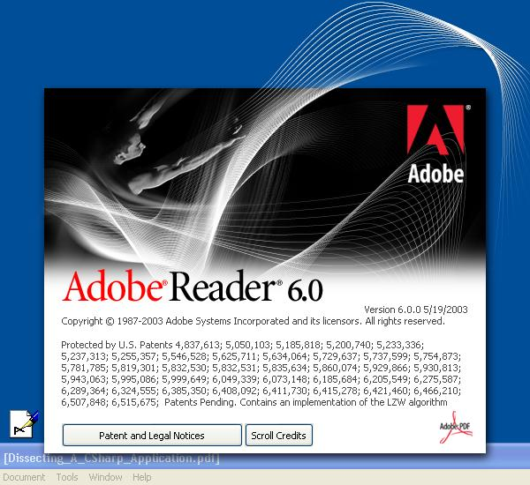
Figure 2: Adobe Acrobat 6.0 Splash Screen

Appendix

Appendix A: Images We Like

We have located various iconic images which we like for various reasons and have been utilizing as examples. Their presence here does not indicate that we wish our images to be modeled after them, but merely attempts to convey various styles, feels, shapes, and colors which we find to be harmonious.

Figure 3: Application Icon Example
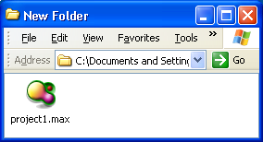

The application icon we have been using internally during development is shown in Figure 3. We like it because is has a “wow” factor, but the colors are pleasant and not overpowering. The fact that the object itself represents nothing in particular is not relevant to us – the elegance of the image is what is important.

Figure 4: Action Icon Example
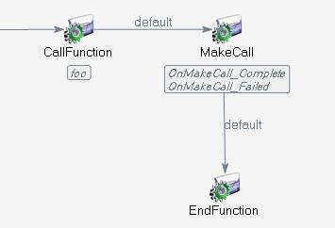

The action icon we have used internally during development is shown in Figure 4. As stated previously, the action icon will be the most important image in the product. We like this particular image for many reasons, among them being:
- It occupies an ideal percentage of the 32x32 pixel space.
- It is essentially rectangular, but not too much so that the canvas appears gridlike.
- The number of colors seems to work well.
- The colors (blue-gray and emeraldy-green) are colors we consider pleasant, which blend well with the product, and which we would like to see used in the future.
- The gradients provide a softness which permits the text to better stand out.
- The image does not unduly attract the eye.

Note that the icon is shown over the actual canvas background color, which is rgb(245,245,245). On a laptop or other non-CRT screen (which has not been calibrated to reduce the monitor’s blue bias), this almost-white gray actually appears as a very pale blue, in the context of the rest of the UI.

Figure 5: Toolbox Icon Examples
Figure 6: Explorer Icon Examples
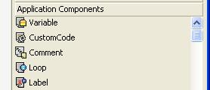
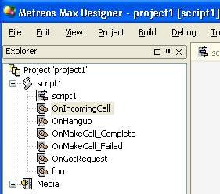
The Explorer and Toolbox icons we have been using temporarily during development are shown in Figure 5 and Figure 6. We like these icons for various reasons, among these being:
- They are essentially rectangular, permitting a columnar appearance.
- They utilize a small number of colors, with a common grayscale background.
- They utilize most of the 16x16 pixel space.
- They leave the first column of pixels transparent (a requirement).
- They have an ideal amount of detail for the 16x16 pixel space.
- The gradients are very nicely done for the 256-color resolution.
- The colors are pleasing, complimentary, and subdued.

Note that in most cases the images do not represent their description. Again, we care much more that the images are classy. Note also that the 256-color resolution is quite elegant here, in combination with the color scheme, simple design, and dithered grayscale gradients. This is not to say that we cannot use higher resolutions, alpha-blending and the like, but is just to demonstrate one feeling which we find pleasing.

Figure 7: Docking Window Icon Examples

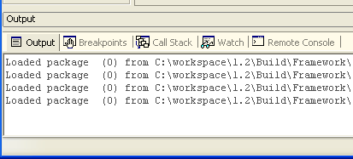

The docking window icons we have been using during development are shown in Figure 7. We have used these for the following reasons:
- They are the icons representing the corresponding windows in Microsoft Visual Studio..
- They are innocuous, almost monochrome, so as to not unduly stand out.

